FAKE NEWS DETECTOR – FINAL PROJECT REPORT
CMPSC 445 – Fall 2025
Ergi Demiraj and Keval Patel

- Description of the Project
This project focuses on building a machine learning–powered Fake News Detection Web Application.
The goal is to classify news articles as fake or real based on their textual content.
The system includes three core components:
- A text classification machine learning model trained using the Kaggle Fake and Real News dataset.
- A Flask-based web application that accepts user text input and predicts whether the news is fake or real.
- A user-friendly interface where users can paste a news headline or article to receive a prediction along with a confidence score.
The project demonstrates the practical application of natural language processing (NLP) and machine learning to a real-world problem involving misinformation.

- Significance of the Project
Online misinformation is one of the most concerning challenges in the digital age.
Fake news can influence political decisions, harm public health, and contribute to misinformation spread across social media.
This project is significant because:
- It shows how machine learning can assist in identifying unreliable information.
- It provides a real-time, interactive tool for detecting misinformation.
- It demonstrates feature engineering, dataset preparation, and model deployment in a meaningful context.
- It raises awareness about misinformation while showing how computational methods can help mitigate it.
Although this system is not intended as a commercial-grade solution, it highlights how automated classification models can support media literacy and research in misinformation detection.

- Code Structure
The project follows a clean, modular design with separation between the training pipeline, model storage, frontend, and backend.
Main Components:
- train_model.py
Handles dataset loading, preprocessing, TF-IDF vectorization, model training, evaluation, and saving of the trained model and vectorizer.
- app.py
The Flask backend that loads saved models, receives user input, performs inference, and returns predictions.
- templates/index.html
The main webpage rendered by Flask. Includes a text area and displays predictions.
- static/style.css
Custom styling for the web interface (dark theme, centered layout).
- model/ folder
Stores the saved Logistic Regression model (fakenews_model.pkl) and vectorizer (vectorizer.pkl).
- Dataset files:
  - Fake.csv (23,481 fake news articles)
  - True.csv (21,417 real news articles)

Code Structure Diagram
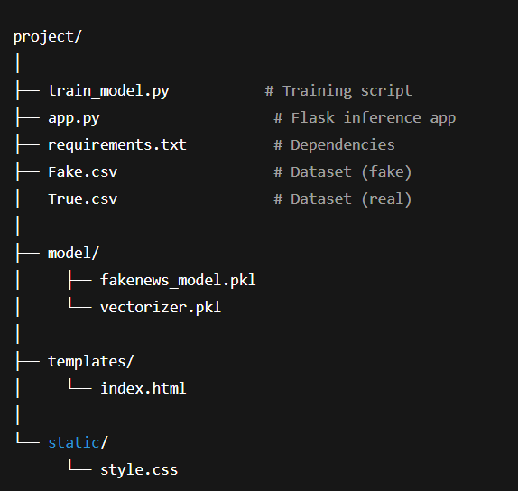

- Functionalities and Test Results
Functionalities
- Accepts user-submitted text via a web interface.
- Preprocesses and vectorizes the input using TF-IDF.
- Predicts whether the article is FAKE or REAL.
- Displays a confidence score.
- Provides clear error messages when no text is entered.
Test Results
- Accuracy: 98.86%
- Precision: 0.99 (Real), 0.99 (Fake)
- Recall: 0.99 (Real), 0.99 (Fake)
- F1-score: 0.99 for both classes
- Test set size: 8,980 samples
These results show that the model generalizes well and reliably distinguishes fake from real news.

- Data Collection
This project uses the Kaggle Fake and Real News dataset.
The dataset consists of:
- Fake.csv – 23,481 labeled fake news articles
- True.csv – 21,417 labeled real news articles
- Total samples: 44,898
Each file contains:
- title — headline of the article
- text — body content of the article
- Additional metadata depending on the sample
The dataset is appropriate because:
- It contains reliable labels.
- It is large enough to train a strong text classification model.
- It reflects real-world linguistic patterns used in misinformation.

- Data Processing and Feature Engineering
Several preprocessing steps were applied:
- Label creation:
  - Fake articles labeled as 1
  - Real articles labeled as 0
- Text enrichment:
  - Combined title + text into a single content field to capture context.
- Shuffling:
  - Randomized ordering using random_state=42.
- Train/test split:
  - 80% training, 20% testing.
- TF-IDF Vectorization:
  - max_features=5000
  - ngram_range=(1, 2) for unigrams + bigrams
  - stop_words='english'
  - Converts text to numerical vectors suitable for machine learning.
These features help capture both individual words and short phrases strongly correlated with misinformation patterns.

- Model Development
The machine learning classifier used is Logistic Regression.
Model Input:
TF-IDF vectorized text (5000 features)
Model Output:
- 1 = Fake news
- 0 = Real news
Algorithm Selected:
Logistic Regression (max_iter=1000)
Training Details:
- Training samples: 35,918
- Test samples: 8,980
- Solver handles sparse TF-IDF matrices efficiently.
- Probability outputs used for confidence scores.
Overall Accuracy:
98.86%

- Discussion and Conclusion
This project demonstrates how machine learning and NLP techniques can be used to detect misinformation at scale. The final model performed exceptionally well, achieving over 98% accuracy.
Project strengths:
- Large, high-quality dataset
- Strong feature engineering via TF-IDF
- Clean and simple Logistic Regression model
- User-friendly web interface
- Clear inference pipeline
Limitations:
- Dataset is limited to English-language articles
- Model may not generalize to new misinformation topics unseen during training
- Only text-based features used (no metadata or network structure)
Future improvements:
- Incorporate additional metadata (source credibility, publication date)
- Add support for multiple languages
- Deploy the app online for public use
Overall, this project applies course concepts effectively and demonstrates real-world machine learning application to a socially important problem.

